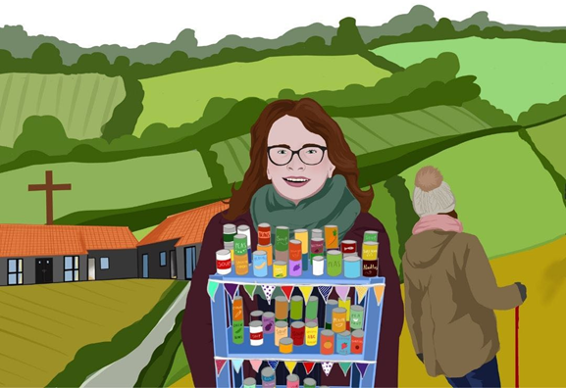



**Dates: 22nd-23rd September 2025**

**Location: St Edmundsbury Cathedral, Bury St Edmunds, Suffolk IP33 1LS**

Dear Friends

Can I draw your attention to the LOVE RURAL conference that is happening here in the District at Bury St Edmunds Cathedral on 22nd to 25rd September.

This will be a great opportunity to learn more about the Church in the Rural Setting. All be it from a mostly Anglican point of view.   This will be a good opportunity for anyone who is either working in a rural setting or indeed interested in hearing and developing a greater understanding of this context.

You can find more information and a full programme by going to [www.bit.ly/loverural](http://www.bit.ly/loverural)

Kind regards

David

Rev'd David McAloon

District Rural Officer