
East Anglia District EDI Autumn 2026 Newsletter

Welcome to our seventh East Anglia District EDI newsletter.

Wedding Welcome – Revd David Ely

I conducted a wedding recently, which was a wonderful occasion. Weddings are mostly wonderful occasions as everyone is pleased to celebrate the love that two people have for each other. What was wonderful about this wedding was the feeling of welcome that was present. The couple were young and the church was full of family and friends of all shapes and sizes, of all genders and colours, of all ages and degrees of faith. In a way it was a microcosm of society in general.

There were those there who would not normally go to a church and those who might find the church to be a difficult place to express themselves. There were also those who had a lifetime of church experience. In this mix of people, I felt a wonderful sense of acceptance and welcome. It wasn’t due to the church’s welcome alone, although that was good; rather it was as if the people had brought the all-embracing welcome with them. There was such joy and acceptance within that representation of society it left a lasting mark on me. I wonder if we as churches, as Christians, take such a welcome with us wherever we go.

Connexional news

The latest Connexional EDI newsletter has been issued and a few highlights from Methodist Conference 2026 on the subject are:

- JDS Sunday – Conference affirmed that a JDS Sunday should be observed across the Connexion on a locally chosen date.
- Inclusive decision-making – Equality Impact Assessments (EIAs) and efforts to improve diversity in leadership were recognised as important developments. Please use EIAs to help in policies, projects and decision making.
- Inclusive worship and language – Preachers and Worship Leaders are encouraged to reflect on the language they use.
- Children and young people – Circuits and Districts are encouraged to provide more accessible, age-appropriate worship, involve young people in leading, and create more opportunities for local gatherings and biblical exploration.
- Supporting ministers – Conference directed the Connexional Council to establish coordinated support for ministers experiencing hate crime, harassment, discrimination or malicious conduct.

The newsletter also contains information about the new rolling recruitment campaign for the Methodist Church’s Solidarity Circles, creating ongoing opportunities for people across the Connexion to express an interest in becoming involved.
The LGBT+, Racial Justice and Rural Communities Solidarity Circles are currently active and work is taking place to recruit new coordinators for the Disability and Women’s Circles so these important groups can be re-established.

There is an interesting article explaining the difference between EDI (used in the UK) and DEI (used in the US). There can be a tendency by some to dismiss equalities recruitment policy as unfairly favouring minorities but this has come from the US where positive discrimination in favour of disadvantaged candidates is allowed. This is illegal in the UK. A minority candidate can only be specifically appointed in the UK is if there is “a Genuine Occupational Requirement”.

Equality, Diversity and Inclusion terms crossword

How many of you had a go at the cryptic crossword which was issued alongside our Summer newsletter? It was too difficult for many of us and Revd Andrew Brazier, Beds, Essex & Herts EDI Officer, has provided this explanation.

“I am not sure how many, if any, attempted the crossword puzzle we set last time. To be fair it was just an experiment and a bit of fun. For those who may have tormented themselves, here is a more fulsome explanation and the answers. The idea in my head was to make the topic of inclusion something approachable and fun. I am sure we have often enough heard EDI wielded like an axe in the face of fun and enjoyment. Most changes in life are only fully accepted once they become intrinsic to all things including humour and play. This is by way of making the excuse for the challenge!

The clues were:

Down

1. (9) Not doing a board game, Dr Black is available at the start, it’s not what you do
but what you should do.
- (3) See 6 down
- (3) See 6 down
- (9) No one looks alike in the dance group
- (4,3,3,3,3) Mark Darcy understands inclusivity – in the order 6 down, 7 down, 2 across, 3 down and 4 down
- (3) See 6 down
7a. (7) In the end are you joining the secret society
- (3) High street clothing store finds it difficult to stay open. It comes between people.
- (2) God

Across
- (2) All welcome in a small pub – endless
- (3) See 6 down
- (7) Getting the cold shoulder means being treated fairly. Only enough for the party.
- (4) Herby wisdom
- (3) Topless glass makes rainbows. No publicity. It is the end of all those bad things.
- (6) Z, millennials, or even X – Cool guy thinks it’s obvious
- (7) Very recent version of a badly sung song when you don’t know the words. At
least there is no bias.

The key to unravelling most cryptic crosswords is to look for a few 'gateway' clues that aren't quite so cryptic. In this one you were given the answer to 1 down, Dr Black is the dead body in the game Cluedo. If you take the do out of Cluedo, you are left with the Clue itself. The Dr is available, or in, at the start giving “INCLUe.” Finally, it’s not the verb but the act: INCLUSION. So you have the word INCLUSION at the side.

Also, the clue at 8 across is just a mini joke. Herby wisdom four letters, is SAGE. The next hint is that 6 down is mentioned multiple times. Therefore a way in, if you happen to know it, is that 6 down references Mark Darcy. In the film Bridget Jones's diary, Mark famously says 'JUST THE WAY YOU ARE - which is a great motto for inclusivity. Even if that one was an unknown to you, 1 across has the word in the clue. A small pub, inn, but endless = IN. 11 down, God but with only two letters is tough, but a quick google search should produce the word EL - Or, of course, you'll get it when you answer 10 and 12 anyway.

10 down is based on the idea of opening a GAP, and we know that high street store. A GAP is also something we find between people. 5 down has a dance group who all look different; DIVERSITY.

Now I have to admit that I am also struggling and learning this stuff, so there were plenty of errors and corrections in there, but having to add a 7a was frustrating. That clue has you joining a CULT, yes UR! CULTURE. 10 across is made up of the word gen, (gen z, generation x etc.) with the statement that it’s obvious der! GENDER. 6 across will need some ICE for that cold shoulder. Treated fairly is JUST and JUST enough ICE to bring those together for the party; JUSTICE.

Finally 9 and 12 were to me the toughest. Hopefully by now you'd have some letters in place to help. 12 across, has no bias to a new tune, badly done. NEUT, without the words is lar, lar, lar - also badly; RAL. So you get NEUTRAL. Finally, there is a spot of philosophy. It seems if you add ism to the end of any word it makes it worse. Racism, sexism, ageism etc. etc. 9 across then is the word prism with the top removed, also ism and finally the prism makes a beautiful LGBTQ+ rainbow!

You should end up with something that looked like this.

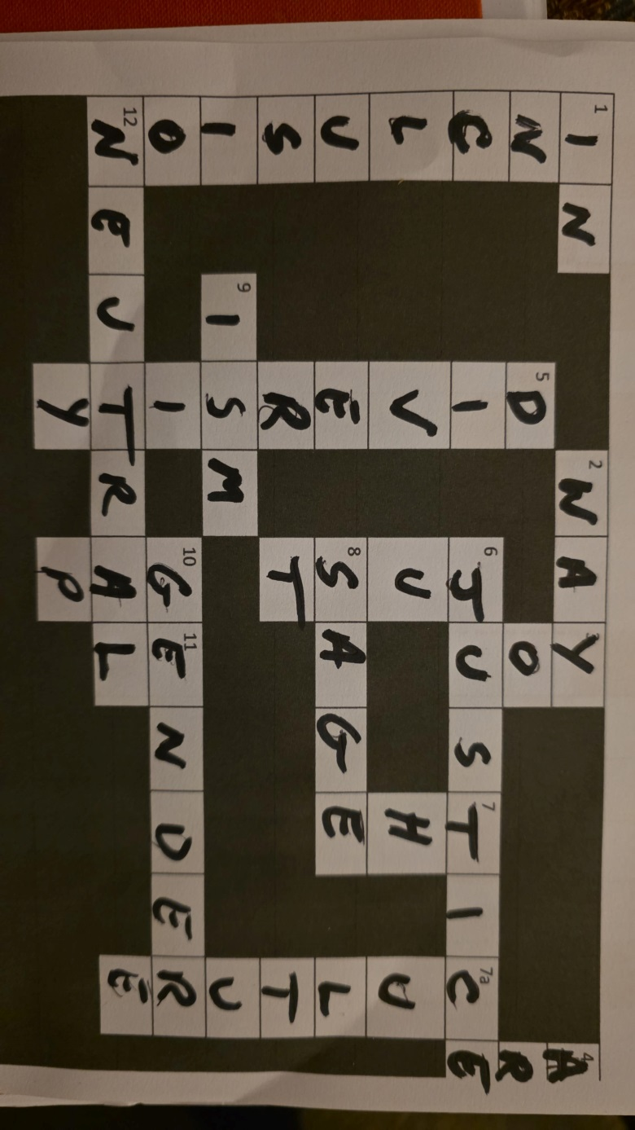

Footnote

This newsletter is again being provided in both a Word and pdf format. Please print a copy for those without internet access who you think would be interested in it.

If you have any EDI thoughts or concerns, please get in touch with Revd Jonny Bell or me.

Susan Eldridge
District EDI Officer

