
East Anglia District EDI Summer 2026 Newsletter

Welcome to our sixth East Anglia District EDI newsletter.

Equality, Diversity and Inclusion

These terms are interconnected but service distinct roles in building a fair environment. From a little searching on the internet I came up with the following:

Equality – this relates to the law and the elimination of barriers to ensure everyone has the same rights and fair access to opportunities and resources and so are treated without discrimination. No individual is disadvantaged based on the protected characteristics such as race, gender, age and disability. All voices carry the same weight.

Diversity – this is ensuring the presence of differences, encompassing the varied backgrounds (e.g. socio-economic or cultural), identities (e.g. ethnicity) and traits that make each person unique. It is about ensuring all groups are represented and have a seat at the table (e.g. in meetings).

Inclusion – this is ensuring that these diverse individuals feel valued, listened to, respected and able to fully participate. It is about a sense of belonging and empowerment.

Perhaps in your Church meetings you can choose to focus on a different one of these each time. You could write the three words on individual pieces of card and then get someone to pick one as your first topic.

Stowmarket Methodist Church

In our Spring newsletter Ros Peedle encouraged Churches to consider what they have done (and could do) to support EDI. Rev Rita Carr has shared with us what has been happening at Stowmarket Methodist Church, focussing on welcome and inclusion.

“Over the weekend 16th and 17th May we celebrated 190 years of worship in our building. We had a drop in coffee and cake event all day on the Saturday. We had flower displays and tables set out in a cross formation which showed what we do now and an area with artefacts and photos from years gone by, including photos of some previous presbyters.

We wanted people to come and join in and to know that we are a welcoming and safe space. The photos on the next page show our new banner which was made and put up ready for our weekend. Inside, along with our displays, we had the balloons showing our age (190) and chose rainbow colours to bring that feeling of inclusivity both inside and out.”

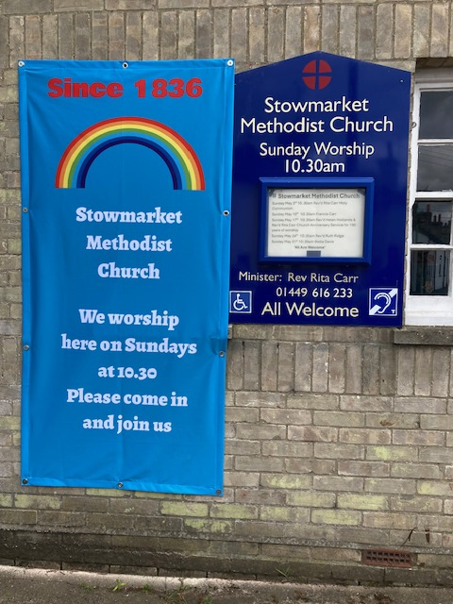

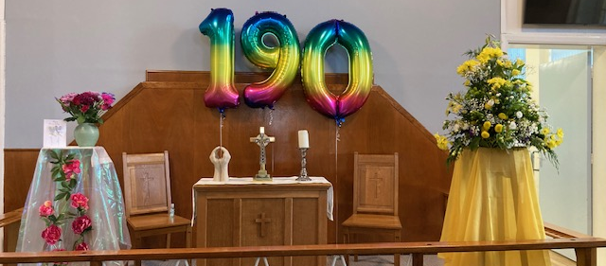
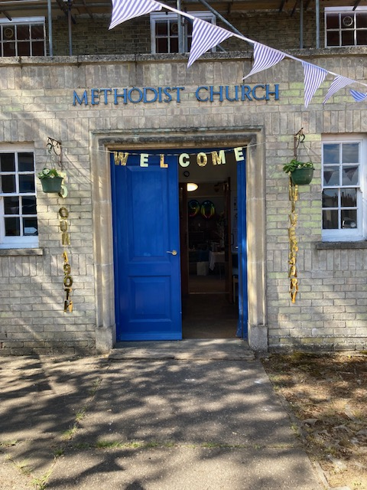
Connexional news

The latest Connexional EDI newsletter has been issued and a few highlights are:

- Asking for any stories that might be useful for the EDI Tool kit (which is being reviewed) to be shared.
- Solidarity Circles – a new strategy for engagement. As a reminder, there are five Solidarity Circles – Disability, LGBTQ+, Racial Justice, Women’s and Rural Church. More information will be out soon.
- An encouragement to use Equality Impact Assessments. More information about these can be found on our District website Equality Impact Assessments
- A look at the differences between EDI, JDS and the Equality Act. It suggests a simple way to remember this is:
  - The Equality Act tells us what the law requires.
  - EDI helps us put it into practice.
  - JDS (Justice, Dignity & Solidarity) provides the Methodist Church’s vision and framework for this work.
  - Together, they help us to build churches and communities where everyone can belong, contribute and flourish.

Footnote

This newsletter is again being provided in both a Word and pdf format. Please print a copy for those without internet access who you think would be interested in it.

If you have any EDI thoughts or concerns, please get in touch with Rev Jonny Bell or me.

Susan Eldridge
District EDI Officer

