
East Anglia District EDI Spring 2026 Newsletter

Welcome to our fifth East Anglia District EDI newsletter. I am delighted that this time we have two articles written by members of the EDI Committee.

Most of you will hopefully be aware that the East Anglia District EDI Committee works in conjunction with the Beds, Essex and Herts (BEH) EDI Committee. The BEH District EDI Officer, Rev Andrew Brazier, has written the following, which includes the more humorous side of his role.

Thoughts from a District EDI Officer

There is a kind of piety around EDI. To be fair, there always is around whatever the latest area of change or revolution is currently upon us. Piety is not always a bad thing. Exclusion is a serious topic, and suffering is not a punchline. There is, however, a measure of how engaged we are with the problem, when it becomes the subject of humour. Doctors, undertakers and bomb disposal experts, in my experience, are often class one wits, and all pretty serious about their jobs. As a District EDI Officer, I get to hear about some of the worst aspects of church life, but I also get the privilege of meeting wonderful people.

In my adventures doing the EDI training, I’ve found myself as a political figure. I accidentally ended up speaking in a village near Clacton the day after Nigel Farage had been there. We had a surprisingly well attended session. On another occasion I found myself in the wrong church being welcomed as someone else, speaking on the topic of ‘my trip to the Holy Land.’ I’ve arrived too early in one place and joined an AA group. I have to say I was very warmly welcomed, and the group was definitely inclusive.

Comedy has also taught us lessons on the way. It was with great mirth and irony that a poorly attended visit to a rural chapel turned out to be the result of no-one remembering to unlock the front door. When people have shared their stories in the meetings, they have also – on many occasions – used humour as a way to open up to the room. Good humour, and not all of it is, is a way of making some tough information palatable, while getting across the profound need for change.

I leave you with a story. Part of my own journey has been one of exclusion on the basis of gender and sexuality, despite being a straight (ish) man. Quite often my brightly coloured scarves and theatrical delivery have led folks to assume that I was gay. We all know what assumptions do to the situation, but this is not that moral lecture. The EDI training is routed in a story-telling exercise that gathered up lived experience to learn from. I still remember the booths in which you could sit and record your story. Maybe you are one of those who submitted your recording. In all honesty I probably didn’t even read the instructions. A number of years later, addressing my first ever face-to-face training session, I proudly led my groups through a discussion on the many case studies. In that moment, I heard my own life story being spoken back to me – for analysis.
I am not sure what is coming along next in life, but I look forward to sharing in this journey with all my fellow wits, twits and you; for we are all included in the Kingdom.

God bless, Andrew

Ros Peedle has written the following article to hopefully inspire other Churches as to what they could do to support EDI. There are a few mission ideas in there as well.

A Church like ours?

Lessingham is a small rural church in North Norfolk. I am the Lay Pastor there with an interest in EDI – Equality, Diversity and Inclusion, possibly having its origins in my professional life in Special Educational Needs or perhaps it is that I believe passionately in all aspects of EDI. This interest led to my response to the request for people to join the District EDI Committee. Initially I felt I hadn’t much to offer from my own Chapel but further thought, and the prompting of other members of the team, made me recognise a number of areas where we are addressing many of these issues. Can you decide under which heading they apply - Equality, Diversity or Inclusion?!

Inclusivity may need unpacking, but basically it means trying to make EVERYONE feel welcome and comfortable. Our Church family consists of a number of less physically-able members who support us by prayer and giving, and a small group of other willing and able folk who support us in practical ways. We currently have a membership of 14. Visitors come and go, some regularly, some occasionally.

Here are some simple things we have tried, costing little more than some thought, and a few more costly modifications which may or may not be beyond your financial resources or what you are prepared to do.

- We were able to declare our church “Dementia Friendly” when we obtained simple signs (with appropriate symbols) for Exit, Toilets, Kitchen etc. These can be found online.
- We make sure there is a box of interesting toys and books in case children join us.
These are placed at the front of the Worship space to show how children and young people are welcome and valued.
- Visual impairment is supported with large print - Hymn books, Bibles, Hymn numbers and Worship books.
- A loop system, received as a gift, supports those with hearing impairment. We encourage everyone to use this and to speak clearly and use jargon-free/accessible language.

- A redevelopment project some 14 years ago allowed us to install DDA (Disability Discrimination Act) compliant toilet facilities (high toilet set with blue seat, rails on either side of the toilet, low light pull etc.). We have wheelchair accessible doorways. Our cooker has an induction hob for safety reasons.
- We have installed Solar panels which help support our electricity bills.
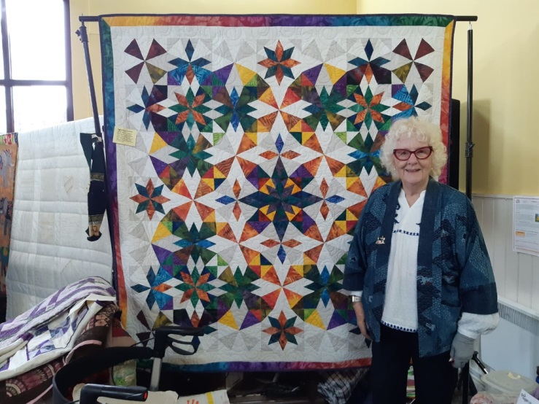
- We have organised a Quilt Exhibition (see the photo) on three occasions which raised more money than we expected.
- We have an annual event when we invite people to come join us for the switching on of the Christmas tree lights.
- We run a monthly Lighthouse Lunch, and twice monthly Lighthouse Café under the “Warm Spaces” Initiative.

We have a quiet/prayer area in the Church with Bible reading suggestions and easy chairs, and a Prayer Tree where folk can hang prayer requests.

Some of our members have followed the EDI training and we regularly discuss other ideas.

We are only a small community but, when we look at it, we are surprised and pleased at how much we have achieved!! I suggest you take a look at your own Church. You might be surprised at what you have already done to support EDI, and a few discussions might reveal some new ideas. I would be very happy to talk with anyone who might be interested and to hear about things you do well. It would also be good to hear about any changes you plan to make so your experiences could be shared with others in a future newsletter.

Ros Peedle – Lessingham Methodist Church Email: ros.peedle@live.co.uk

Footnote

This newsletter is again being provided in both a Word and pdf format. Please print a copy for those without internet access who you think would be interested in it.

If you have any EDI thoughts or concerns, please get in touch with Rev Jonny Bell or me.

Susan Eldridge
District EDI Officer

