**CONFIRMATION RESOURCES**

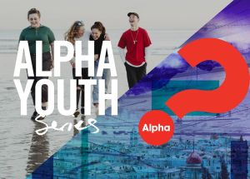

**Youth Alpha**: <https://alpha.org.uk/youth>

Brand new course revised: 10 sessions over 8 weeks – video based & discussion /conversation

**Christianity Explored: SOUL**: <https://www.christianityexplored.org/courses/shop/christianity-explored/soul/>

7 week video & discussion-based material



**Vox: Share what matters:** https://www.christianityexplored.org/courses/vox/

4 week video session using Luke’s Gospel: What’s life all about? Where do I belong? How can I find meaning and purpose? And what’s that all got to do with Christianity?

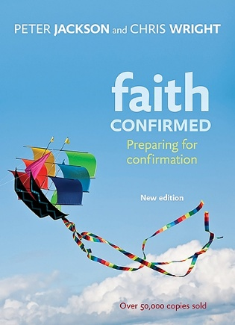

**FAITH CONFIRMED**

Workbook / sessions: ‘Faith Confirmed’ is the bestselling resource for guiding spiritual wanderers into the Anglican faith. The confirmation participants guide covers every aspect of Christian living, preparing the heart and minds of individuals and groups.

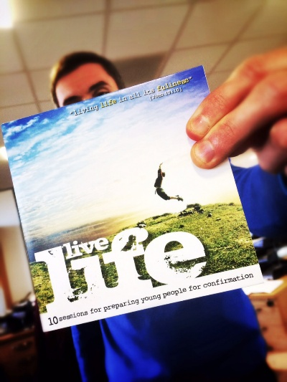**LIVE LIFE – Booklet / 10 session outlines**

Live Life’ is fresh and flexible resource that introduces young people to the Christian faith and prepares them for Confirmation within the Anglican Church.

Through ten interactive and engaging sessions ‘Live Life’ aims to create safe spaces for young people to discuss, question and deepen their understanding of God. Each session follows a familiar and flexible structure with practical guidance for enthusiastic volunteers through to experienced youth workers and church leaders.

<https://www.bristol.anglican.org/churchlife/resourcesforparishes/childrenyoungpeopleministry/live-life-resource/>

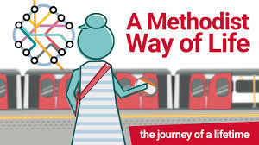

**Adapting Methodist Way Of Life Resources**

<https://www.methodist.org.uk/faith/a-methodist-way-of-life/>

***POINTS TO NOTE***

*When I have run confirmation resources for young people, using a variety of resources, I have always included a session specifically on the Methodist Church e.g What makes Methodism distinctive, often titled Why Methodism?*

*7.5.25*