Christmas Cribs and Trees

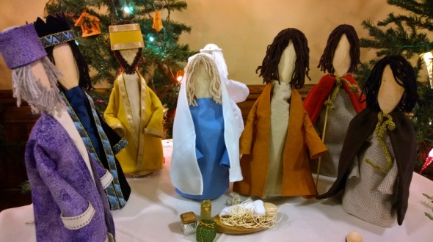

A Festive Display

at Rosebery Road Methodist Church

Norwich NR3 3AB
Donations to

The Brain Tumour Charity

December 4th, 5th, 10th, 11th &12th

10.30 am – 4.00pm

Sundays 5th and 12th from 12 noon
Christingle Service at 4pm on 12th

Organ recitals by Tim Patient on both Saturdays
from 11 am to noon

Refreshments, craft and second hand book stalls each day for church expenses. Parking in school car park opposite at weekends by kind permission of the head

