death on the tree

preaching on the Cross
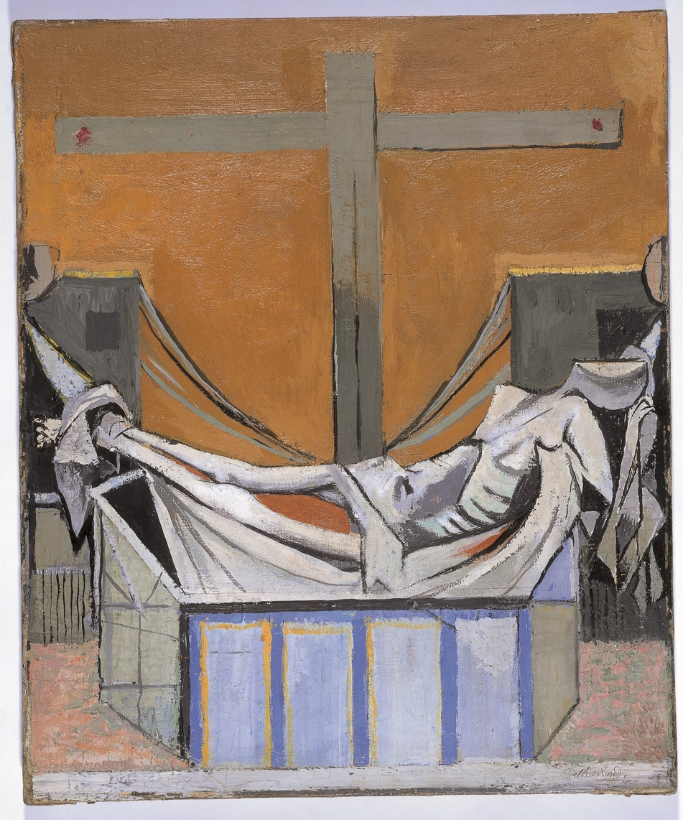

Themes explored:

- The image of the Tree:
symbol of life renewed

- The cross in the Bible

- Worship and the Image of the Cross

A STUDY DAY FOR LOCAL PREACHERS

10.30am - Saturday 7th March 2020
Trinity Methodist Church, Wisbech

Led by Revd Adam J Stevenson and Revd Debbie Caulk
Please book by emailing fenscircuit@outlook.com
Bring a packed lunch – Trinity Coffee

